NASTP Institute of Information Technology


Submitted To: Sir Hammad

Submitted By: Huzaifa Hassan

Rollno : S2025AI036

Semester: 4th Semester – Fall 2026

Subject: AI LAB

1. Objective
The objective of this laboratory session is to synthesize Object-Oriented Programming (OOP) paradigms with fundamental Python data structures to construct domain-specific management architectures:
- Implementing inheritance hierarchies using superclass and subclass abstractions across three distinct application domains (Library, Hospital, and E-Commerce).
- Integrating Python's primary built-in data structures (list, dict, set, tuple) based on asymptotic access times, mutability constraints, and collection uniqueness.
- Managing application state transitions, entity checkouts, FIFO queues, capacity constraints, and transaction processing.
- Utilizing method overriding, delegation via super().__init__(), and object encapsulation to design clean, modular software solutions.
2. Theory
2.1 Object-Oriented Architecture and Inheritance
Inheritance promotes code reuse and models hierarchical relationships:
- Base Classes (LibraryItem, Person, Product): Abstract shared fields (e.g., identity codes, names, base status) and common behaviors.
- Derived Classes (Book, Doctor, Electronics, etc.): Specialize the parent class by introducing domain-specific fields while leveraging the constructor of the parent via super().__init__().
2.2 Data Structure Selection in System Design
The four primitive data structures in Python are selected based on operational requirements:
Data Structure | Mutability | Ordering | Lookup Complexity | System Application
list | Mutable | Ordered (Sequence) | $O\left(N\right)$ linear search | Sequential catalogs, queues (FIFO), and shopping carts
dict | Mutable | Key-Indexed | $O\left(1\right)$ average hash lookup | Fast primary-key searching (item_id, doctor_id, product_id)
set | Mutable | Unordered (Unique) | $O\left(1\right)$ average membership test | Duplicate prevention (categories, medical ailments, product tags)
tuple | Immutable | Ordered (Sequence) | $O\left(1\right)$ index access | Fixed configuration metadata (GPS coordinates, hospital limits, regions)
2.3 Computational Invariants and State Transitions
- Constant Time Hash Lookups: Storing objects in hash maps allows operations like checkout, doctor dispatch, and cart validation to execute in $O\left(1\right)$ time rather than traversing an entire catalog via $O\left(N\right)$ sweeps.
- Set Invariance: Sets use hash values to guarantee uniqueness:
$$S∪\left\{x\right\}=S \text{if }x∈S$$
This prevents redundant category or tag entries without requiring explicit linear membership checks.
- Immutability Protection: Encapsulating boundary configurations (such as hospital capacity or branch IDs) inside tuples prevents runtime tampering or unintended state mutations.
3. Tools / Software / Libraries
- Language: Python 3.x
- Development Environment: Visual Studio Code / Terminal
- Libraries: Standard Built-in Python Runtime (no external packages required)
4. Procedure / Methodology
- System 1: Library Management System
  - Constructed the base class LibraryItem with title, id, category, and initialized status as "Available".
  - Subclassed Book (adding author, page_count) and Magazine (adding issue_number), delegating common attributes via super().__init__().
  - Designed the Library controller class initializing a list (catalog), a dictionary (search_index), a set (categories), and an immutable tuple (metadata).
  - Implemented add_item() to register objects across the list, dictionary, and set simultaneously.
  - Implemented checkout() using $O\left(1\right)$ dictionary lookup to toggle availability status.
  - Built display_summary() to iterate across the catalog and report item status via formatted strings.
- System 2: Hospital Management System
  - Created the base class Person with name, age, and id_number.
  - Derived Doctor (adding specialty, years_of_experience) and Patient (adding ailment, blood_type).
  - Built the Hospital management class encapsulating a patient_queue list, a staff_directory dictionary, a departments set, an active_ailments set, and a hospital_config tuple storing bed capacity.
  - Implemented admit_patient() with an integrated capacity check against the tuple configuration limit, appending to the queue and updating active ailment records.
  - Implemented assign_doctor() using the dictionary to verify physician credentials and map them to the selected patient.
  - Formulated a daily rounds method that sequentially visits each admitted patient in the queue.
- System 3: E-Commerce Backend System
  - Defined the base class Product featuring product_id, name, price, and stock_level, along with the apply_discount() method.
  - Subclassed Electronics (warranty_period, brand) and Clothing (size, material).
  - Built the Store controller class holding an inventory dictionary, a shopping_cart list, and a shipping_regions tuple.
  - Implemented add_to_cart() by locating items via $O\left(1\right)$ dictionary lookups, verifying positive stock balances, appending items to the cart list, and decrementing warehouse inventory.
  - Developed calculate_total() to compute order costs using accumulator loops.
  - Built filter_by_tag() to evaluate tag set intersections and identify matching inventory items.
6. Observations
- Integrating dual storage formats (e.g., maintaining an item in both a list for sequence tracking and a dict for indexed lookups) provides both ordered traversal and fast retrieval at the expense of minimal memory overhead.
- Sets automatically discard duplicate inputs when ingesting multi-source categories, medical conditions, and product tags without requiring manual membership checks.
- Tuples prevent inadvertent reassignment of critical application constants (such as bed limits or store metadata).
- Calling super().__init__() ensures parent class initializations remain standardized, preventing attribute omission across specialized child classes.
7. Analysis / Discussion
- Memory vs. Retrieval Efficiency: In all three systems, using a dictionary for primary key lookups (search_index, staff_directory, inventory) guarantees $O\left(1\right)$ average-time access. In contrast, searching sequentially through a list of $N$ items requires $O\left(N\right)$ operations. Maintaining a reference to the same object within both a list and a dictionary avoids data duplication because both containers store pointers to the identical underlying object in heap memory.
- Defensive Invariant Enforcement: Using a set for departments in the Hospital system and categories in the Library system prevents duplicate entries by design. Any redundant insertion is ignored, ensuring consistent reporting across system operations.
- Data Integrity via Immutability: Storing configuration boundaries (such as Total_Beds in the hospital or shipping_regions in the store) within tuples protects against accidental modification during execution, making them well-suited for static application parameters.
8. Conclusion
The laboratory demonstrated practical integration between Object-Oriented design and Python's primary data structures. Base-derived class hierarchies established modular domain models, while pairing lists, dictionaries, sets, and tuples with specific operational roles achieved efficient, structured data handling across all three enterprise scenarios.

System 1: Library Management System
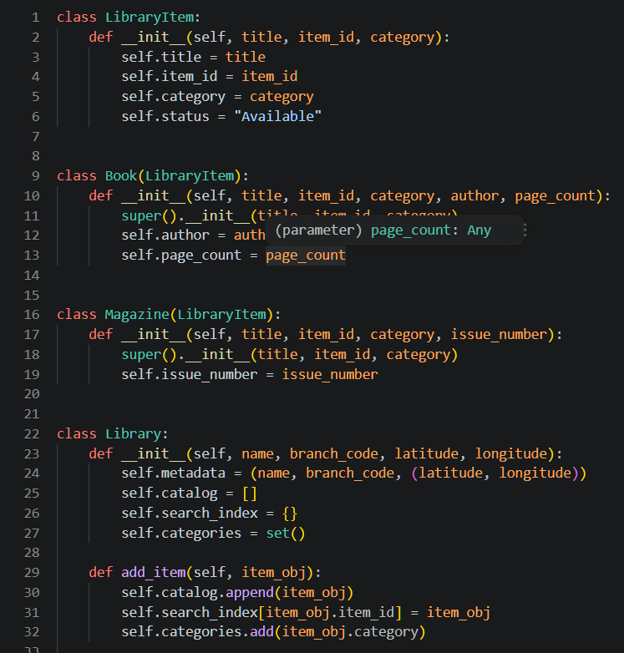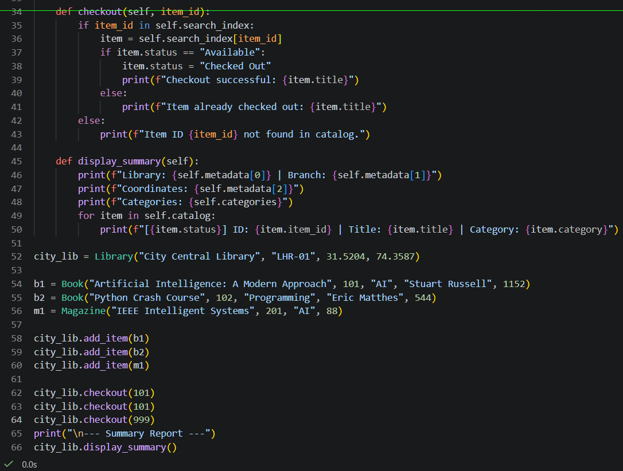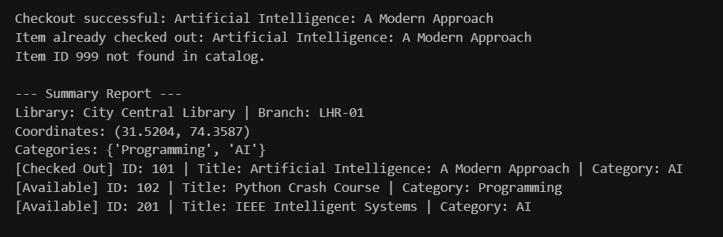

System 2: Hospital Management System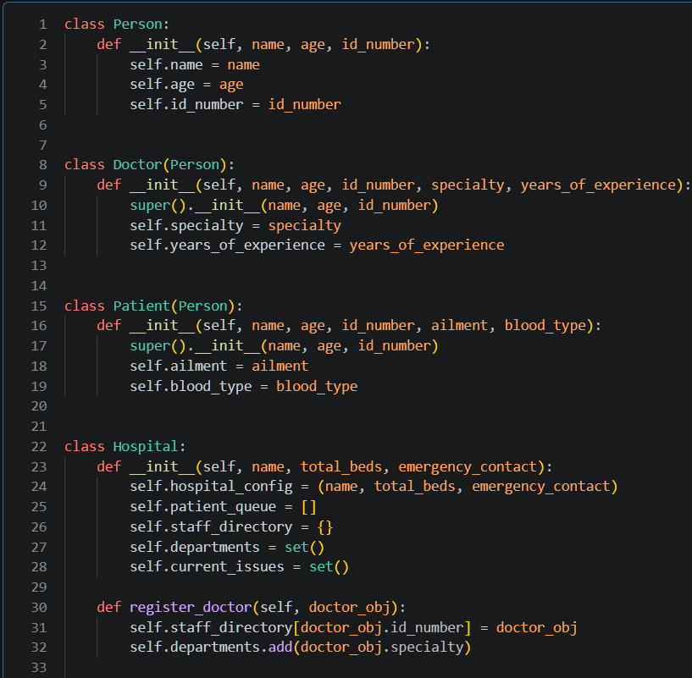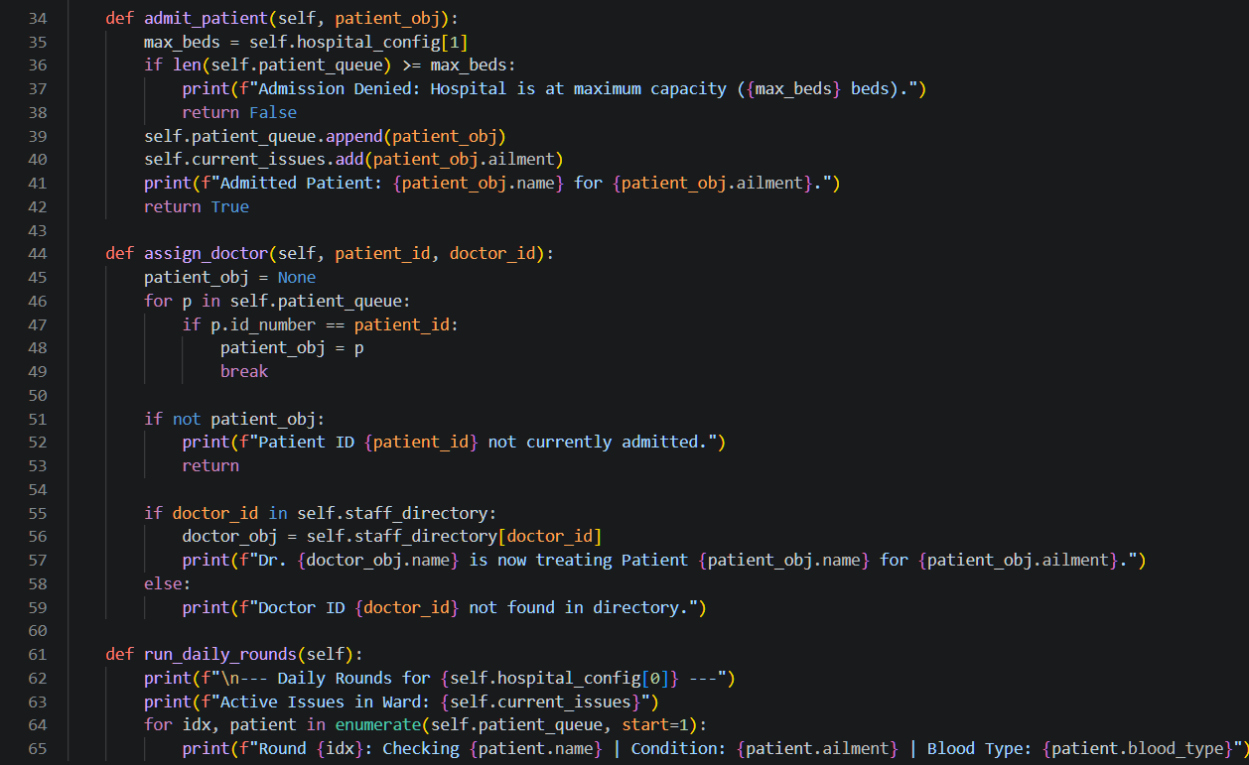
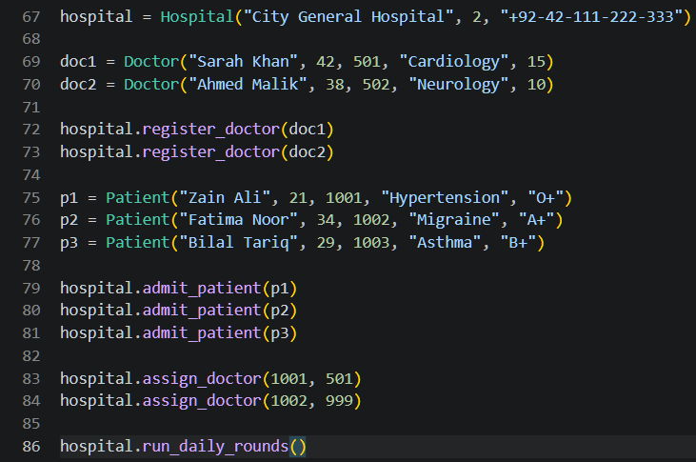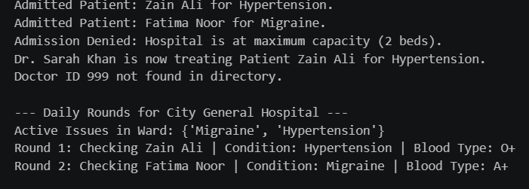

System 3: E-Commerce Backend System